**Topic:** The Final Books of the Elements

**Notes on Topic:** Final Books of the Elements:  
Book VII though IX Euclid proved 102 propositions about whole numbers  
Then, in the longest and most sophisticated of all the books with 115 propositions, Book X, Euclid takes a turn and discussed incommensurable magnitudes, in modern times this is referred to expressions involving square roots of real numbers  
**Prop X.96**: *if an area be contained by a rational straight line and a sixth apotome, the side of the area is a straight line which produces with a medial area a medial whole*

// this is one example of the intricate work of Euclid, today many of these propositions seem obsolete due to the rational and irrational number systems

Books XI through XIII are concerned with solids or three dimensional geometry  
The eleventh book has 39 propositions involving the solid geometry of intersecting planes, plane angles and so on

One of the major results, Prop XI.21: involving a solid angle, for example the apex of a pyramid, formed by three or more plane angles at a meeting point, Euclid proved that the sum of the plane angles at this point is less than four right angles  
Book XI dealt with elementary propositions about solid geometry

Book XII dove deeper into the geometry of solids

For example Prop XII.10 looked at Eudoxus’ method of exhaustion to address issues such as the volume of a cone  
Prop XII.10: Any cone is a third part of the cylinder which has the same base with its equal height, many years later Archimedes would attribute this proposition to Eudoxus

Surprisingly Prop XII.2 (another great result) involves a plane circle, “Circles are to one another as the squares on their diameters” // This result is touched on by Hippocrates, this is comparing areas and diameters of two circles, not determining an area from a given diameter // A1/D1^2 = A2/D2^2   
The ratio of the circles area to the square of its diameter is constant, although Euclid did not tough on the numerical value of this constant, although I am sure we can assume…..  
The last proposition of Book XII is the three dimensional equivalent, “spheres are to one another in triplicate ratio of their respective diameters”  
  
The Final Book involves 18 propositions of “regular solids”  
To the Greeks, the regular solids represented the epitome of beauty and symmetry  
Five solids were known: tetrahedron (pyramid with an equilateral triangle at each of its four faces), the cube, the octahedron (equilateral triangles at each of its eight faces), dodecahedron (regular pentagons at each of its twelve faces), icosahedron (a 20-faced solid with equilateral triangles as faces)  
These were also featured in Plato’s Timaeus, around 350 BC, he considered each of the four elements -- fire, water, air, earth -- these could only have been created out of perfect bodies, so it seemed clear to Plato that each element was one of the regular solids  
The final proposition, Euclid proved that there can be no more regular solids other than the five listed above, this proof is sophisticated in nature and relies on Prop XI.21

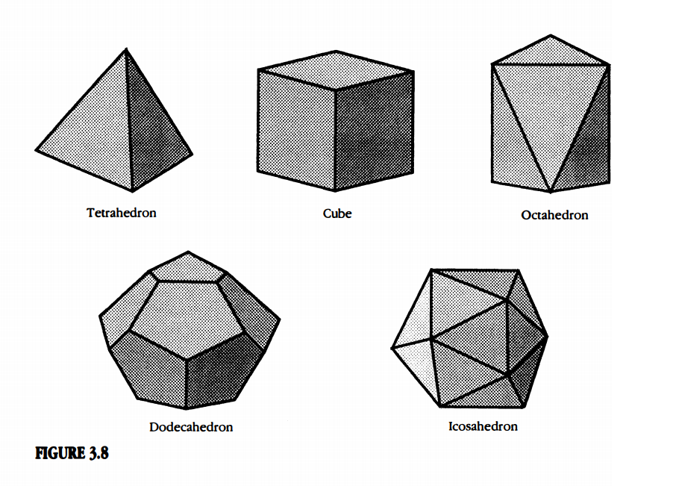

**open the book and read the explanation here, Pp 80** great discussion!!

Why can there only be five regular solids?

* Examine solids with triangles as the faces (each vertex 60 degrees)
* Examine solids with squares as the faces (each vertex 90 degrees)
* Examine solids with pentagons as the faces (each vertex 108 degrees)

And with this discussion, the Elements come to an end. Truly a test of time for Euclid, still a modern day marvel.

**In Class Activity:** Homework Problem 55

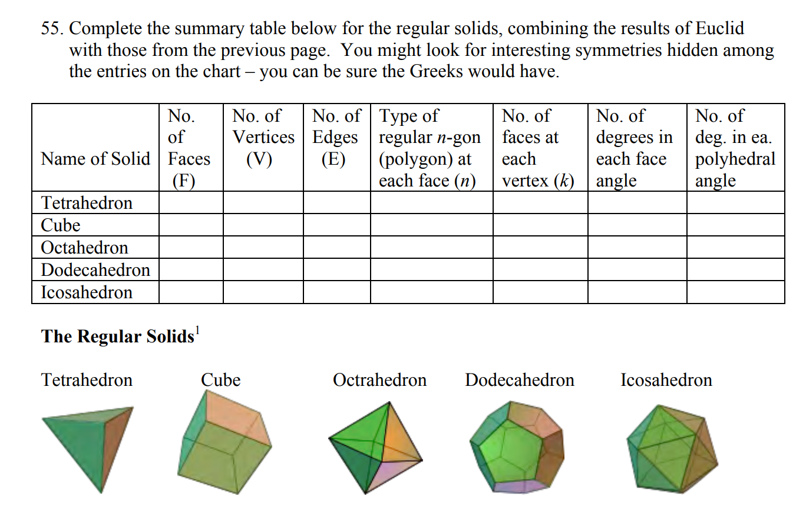

**Additional Suggested Reading**: Epilogue, Chapter 3

**Assignment:** None